EDOCS
Enterprise E-Contracts & Digital Document Management Platform

Project Documentation
Problem Statement | System Architecture | Class Diagram | Technical Roadmap

Version 1.0 | September 2026

Table of Contents

- Executive Summary

- Problem Statement

- Solution Overview & Key Features

- System Class Diagram

- Architecture Comparison

  - Monolithic Architecture

  - Microservices Architecture

  - Event-Driven Architecture

  - Recommendation & Rationale

- Security & Compliance Framework

Executive Summary
Edocs is a next-generation enterprise platform designed to eliminate paper-based contract management and replace it with a secure, legally-binding digital ecosystem. The platform provides end-to-end e-contract lifecycle management — from creation and negotiation to e-signature execution, automated workflow orchestration, and long-term compliant archiving.
Unlike generic document tools or simple e-signature apps, Edocs is built for enterprise-grade requirements: multi-party contract negotiation, role-based access control, immutable audit trails anchored to blockchain, AI-powered document analysis, and full compliance with global electronic signature regulations including eIDAS (EU), ESIGN Act (USA), and UETA.
The platform targets law firms, real estate agencies, financial institutions, HR departments, and any organization that processes high volumes of agreements requiring legal enforceability, version control, and tamper-proof storage.

Problem Statement

The Paper Problem
Despite digital transformation across industries, contract management remains one of the last bastions of paper dependency. Organizations face a cascade of interconnected problems:
    - Operational Inefficiency: Printing, scanning, couriering, and manually filing contracts adds 3-5 days to average turnaround time. A typical NDA that could be signed in minutes takes 2-4 business days on paper.
    - Cost Burden: Organizations spend $20-$50 per paper contract in printing, shipping, storage, and labor costs. For a mid-size company processing 10,000 contracts annually, this exceeds
$300,000 in direct costs.
    - Risk of Loss & Tampering: Physical documents are vulnerable to fire, flooding, misplacement, and unauthorized alteration. 7.5% of all paper documents are lost completely, and 3% are misfiled.
    - No Real-Time Visibility: Stakeholders cannot track contract status in real time. 'Where is my contract?' is one of the most common questions in legal and procurement departments.
    - Compliance Gaps: Paper archives make it nearly impossible to demonstrate GDPR data retention compliance, SOX audit trails, or eIDAS-qualified signature requirements.
    - Remote Work Friction: In distributed teams, paper processes create bottlenecks. 68% of remote workers report document signing as their top operational frustration.
    - Version Chaos: Multiple parties editing different versions of the same contract via email creates confusion, legal risk, and execution of incorrect terms.
    - Search & Retrieval Nightmare: Finding a specific clause in a paper archive takes an average of 18 minutes. Digital search reduces this to under 2 seconds.

Market Gap
Existing solutions fall into two inadequate categories: (1) simple e-signature tools (DocuSign, HelloSign) that lack contract lifecycle management, and (2) document management systems (SharePoint, Google Drive) that lack legal enforceability and signature compliance. Edocs bridges this gap by combining both capabilities in a unified, compliance-first platform.

Solution Overview & Key Features
Edocs is architected as a modular, API-first platform that can be deployed as a cloud SaaS, private cloud, or on-premises solution. The following features differentiate Edocs from incumbent solutions:
- Smart Contract Builder: Drag-and-drop contract authoring with 200+ pre-vetted templates (NDA, MSA, Employment, Lease, SLA). Dynamic field injection from CRM/ERP data.
AI-powered clause suggestion based on contract type and jurisdiction.
- Multi-Party E-Signature Engine: Supports simple electronic signatures, advanced signatures (AATL-compliant), and qualified electronic signatures (QES/eIDAS). Sequential and parallel signing workflows. Biometric capture, ID verification, and liveness detection for
high-value contracts.
- Real-Time Collaboration: Microsoft Word-like collaborative editing with redlining, comment threads, and suggestion mode. Real-time cursor presence and change tracking. Conflict resolution for simultaneous edits.
- Automated Workflow Orchestration: Visual BPMN 2.0 workflow designer. Conditional routing based on contract value, party type, or risk score. Automated approval hierarchies, reminders, and escalation paths. Integration with Zapier, Make, and enterprise BPM tools.
- Immutable Audit Trail: Every view, edit, share, and signature is cryptographically hashed and anchored to a public blockchain (Ethereum or Hyperledger). Tamper-evident logs with timestamps, IP addresses, and geolocation. Court-admissible evidence packages.
- AI Document Intelligence: OCR extraction from scanned PDFs and images. Named Entity Recognition (NER) for parties, dates, monetary values, and obligations. Risk scoring based on clause analysis. Automatic compliance checking against internal playbooks.
- Enterprise Archive & Search: WORM-compliant (Write Once Read Many) storage. Full-text search across 50+ document formats. Smart folders, tags, and metadata schemas. Automated retention policies with legal hold capabilities.
- Granular Access Control: Role-Based Access Control (RBAC) and Attribute-Based Access Control (ABAC). Organization-level tenant isolation. Field-level encryption for sensitive data. SSO integration (SAML 2.0, OIDC, LDAP).
- API-First Integration: RESTful and GraphQL APIs with comprehensive SDKs (Python, Node.js, Java, C#). Webhook subscriptions for real-time event notification. Pre-built connectors for Salesforce, HubSpot, SAP, Microsoft 365, and Google Workspace.
- Advanced Analytics: Contract velocity dashboards (time-to-signature). Bottleneck identification in workflows. Compliance posture scoring. Predictive analytics for renewal dates and risk exposure.
- Mobile-First Experience: Native iOS and Android apps with offline document access. Push notifications for signature requests. Camera-based document scanning with auto-deskew and enhancement.
- White-Label Capability: Full white-labeling for enterprise clients including custom domains, branded emails, and embedded signing experiences within client applications.

System Class Diagram
The following class diagram illustrates the core domain model of the Edocs platform. The design follows Domain-Driven Design (DDD) principles with clear aggregate boundaries, value objects, and domain events.
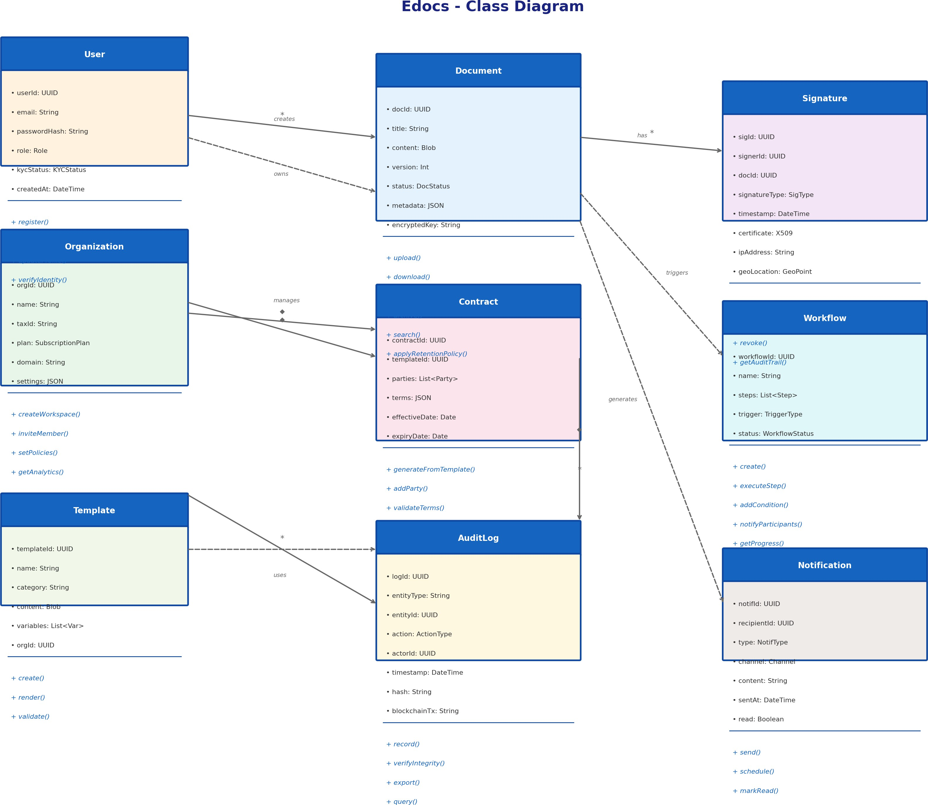
Figure 1: Edocs Core Domain Class Diagram

Key Design Decisions:
- User & Organization: Multi-tenant design with organization-scoped data. KYC status enables identity-verified signatures for high-assurance contracts.
- Document & Contract: Contract extends Document with party-specific terms and lifecycle management. Version control prevents data loss during collaborative editing.
- Signature: Captures X.509 certificate data, IP geolocation, and timestamp for non-repudiation. Supports multiple signature types (click-to-sign, drawn, digital certificate).
- Workflow: Decoupled from contracts via events, enabling reusable workflow templates across different document types.
- AuditLog: Immutable by design. Blockchain transaction hash provides external verification of log integrity.
- Template: Variable substitution engine enables dynamic contract generation from structured data sources.

Architecture Comparison
This section presents three architectural approaches for the Edocs platform, analyzing their trade-offs across dimensions of scalability, complexity, maintainability, cost, and time-to-market. Each approach is evaluated against the specific requirements of an e-contract and document management system.

Monolithic Architecture
In the monolithic approach, all business capabilities — authentication, document management, contract generation, e-signatures, workflows, and analytics — are packaged and deployed as a single unitary application. The architecture is straightforward: clients connect through an API Gateway, requests are load-balanced across multiple instances of the same application, and all modules share a unified database layer.
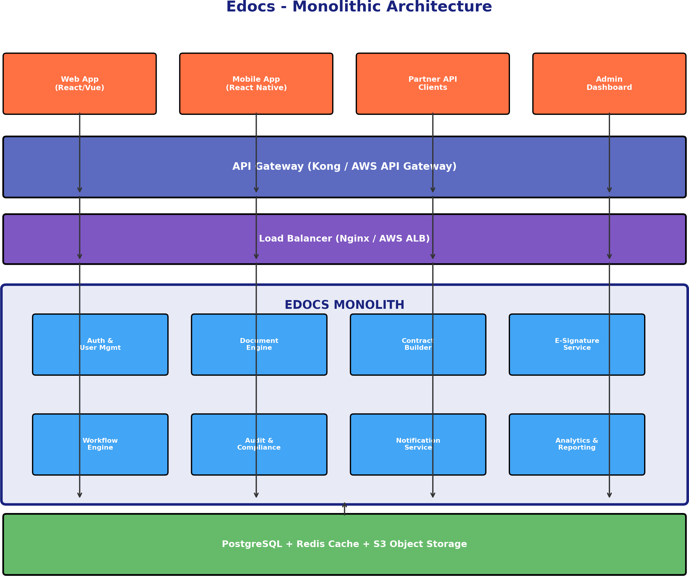

Figure 2: Monolithic Architecture Diagram

Advantages:
- Simplicity: Single codebase reduces cognitive load. Developers can trace any request through the entire stack.
- Fast Development: No inter-service communication overhead. Ideal for MVP and rapid prototyping.
- Simplified Testing: End-to-end integration testing is trivial — everything runs in one process.
- Operational Simplicity: Single deployment artifact. Monitoring, logging, and debugging require one toolchain.

- Data Consistency: ACID transactions across all modules using a single PostgreSQL instance.
- Lower Infrastructure Cost: One application server and one database cluster for initial deployment.

Disadvantages:
- Scalability Bottleneck: Cannot scale individual components independently. If e-signature processing is slow, the entire application must be scaled.
- Tight Coupling: Changes in the contract module may inadvertently affect the signature module. Risk of regression increases over time.
- Technology Lock-in: Entire stack must use the same language and framework. Cannot adopt specialized databases (e.g., graph DB for relationships).
- Deployment Risk: Any change requires redeploying the entire application. Downtime windows are unavoidable without blue-green deployment.
- Team Scaling Issues: Large teams working on one codebase create merge conflicts and coordination overhead.

Microservices Architecture
The microservices architecture decomposes Edocs into independently deployable services, each owning a specific business capability. Services communicate via REST/gRPC (synchronous) and a message broker (asynchronous). Each service has its own database, enabling polyglot persistence and independent scaling.
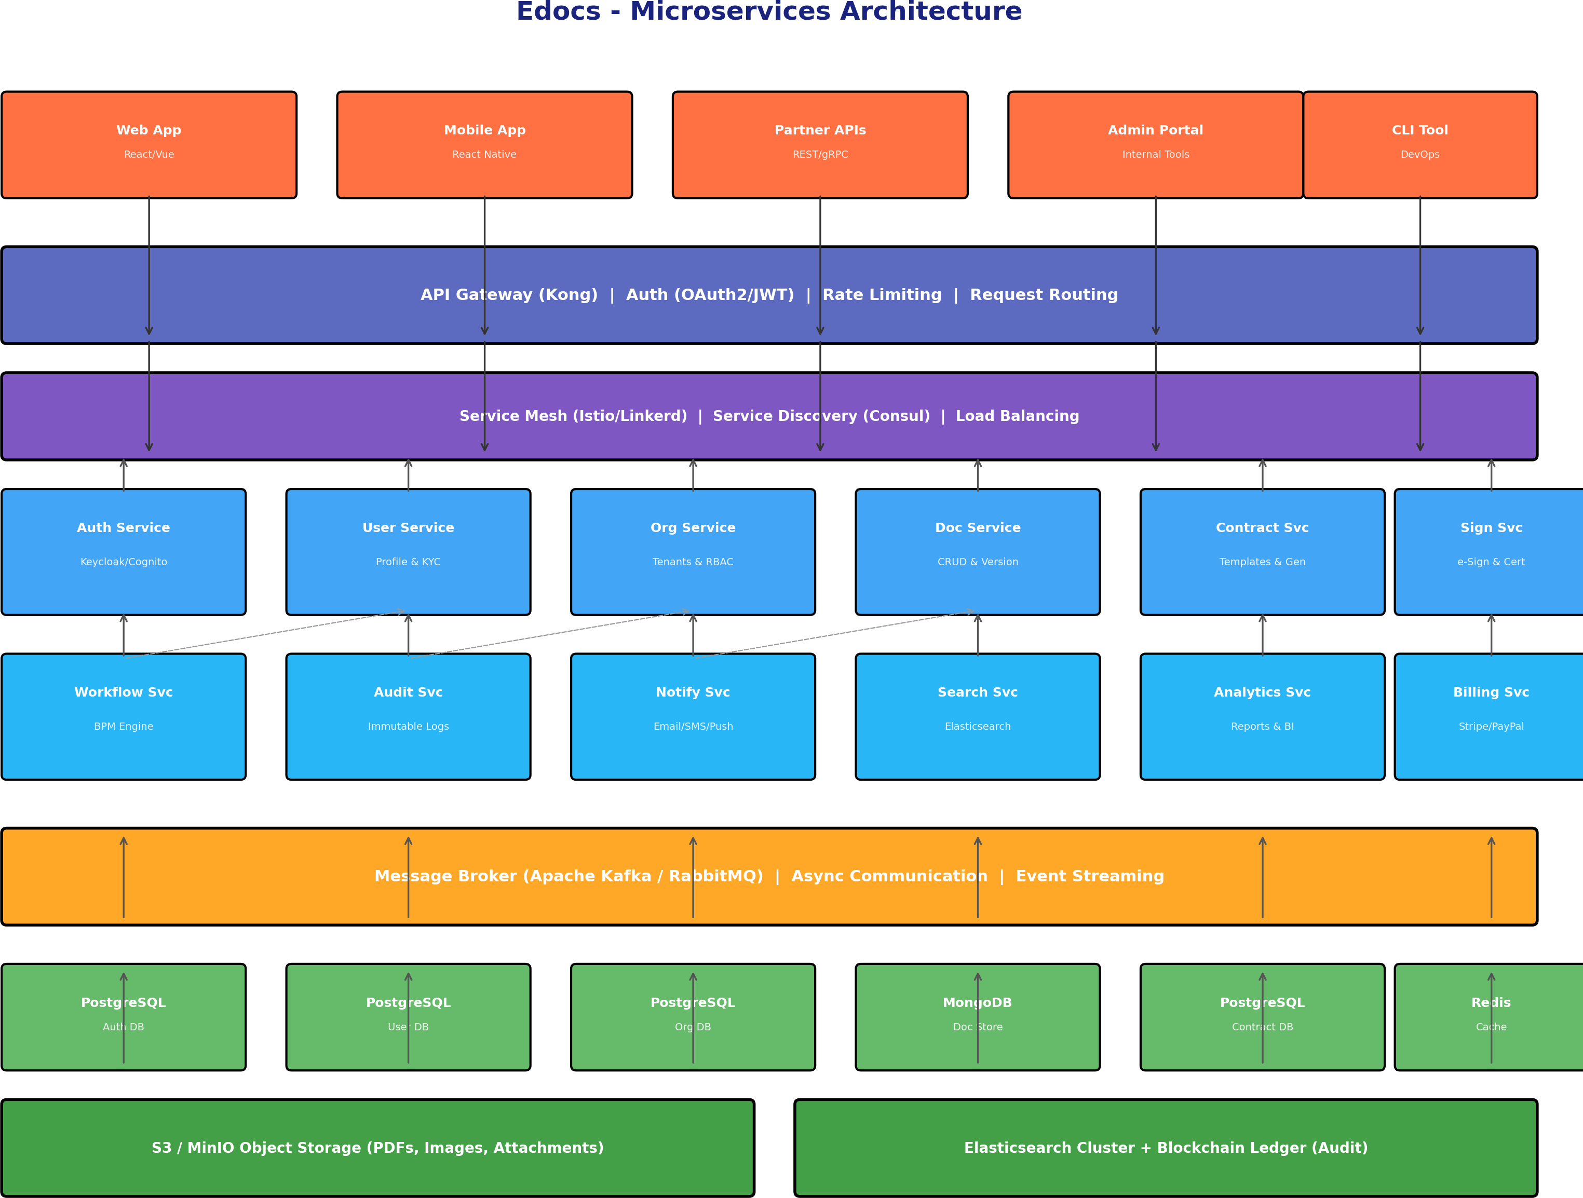
Figure 3: Microservices Architecture Diagram

Advantages:
- Independent Scalability: The e-Signature Service can scale to 50 instances during peak signing periods while the Analytics Service runs on 2 instances.
- Technology Flexibility: The Document Service can use MongoDB for flexible schemas, while the Contract Service uses PostgreSQL for relational integrity.
- Team Autonomy: Small, cross-functional teams own services end-to-end. Parallel development without merge conflicts.
- Fault Isolation: If the Analytics Service fails, contract signing and document management continue unaffected.
- Independent Deployment: Deploy the Notification Service 10 times a day without touching the Audit Service.
- Polyglot Programming: AI Document Intelligence can be built in Python (TensorFlow), while core APIs remain in Java/Spring Boot.

Disadvantages:

- Operational Complexity: Requires service mesh (Istio), service discovery (Consul), distributed tracing (Jaeger), and centralized logging (ELK).
- Data Consistency Challenges: Distributed transactions require Saga patterns. Eventual consistency complicates user experience (e.g., 'signed' event may not immediately reflect in search index).
- Network Latency: Inter-service calls add 5-50ms per hop. Deep call chains degrade performance.
- Higher Infrastructure Cost: Each service needs its own database, cache, and potentially dedicated compute. Minimum 3x infrastructure cost vs. monolith.
- Testing Complexity: Contract testing (Pact), integration testing across services, and chaos engineering are mandatory.
- Steep Learning Curve: Team must master Docker, Kubernetes, CI/CD pipelines, and observability tooling before delivering value.

Event-Driven Architecture
The event-driven architecture places an event bus (Apache Kafka) at the center of the system. All state changes are emitted as events. Services are consumers that react to events rather than directly calling each other. This design embraces Event Sourcing and CQRS (Command Query Responsibility Segregation), making the event log the single source of truth.
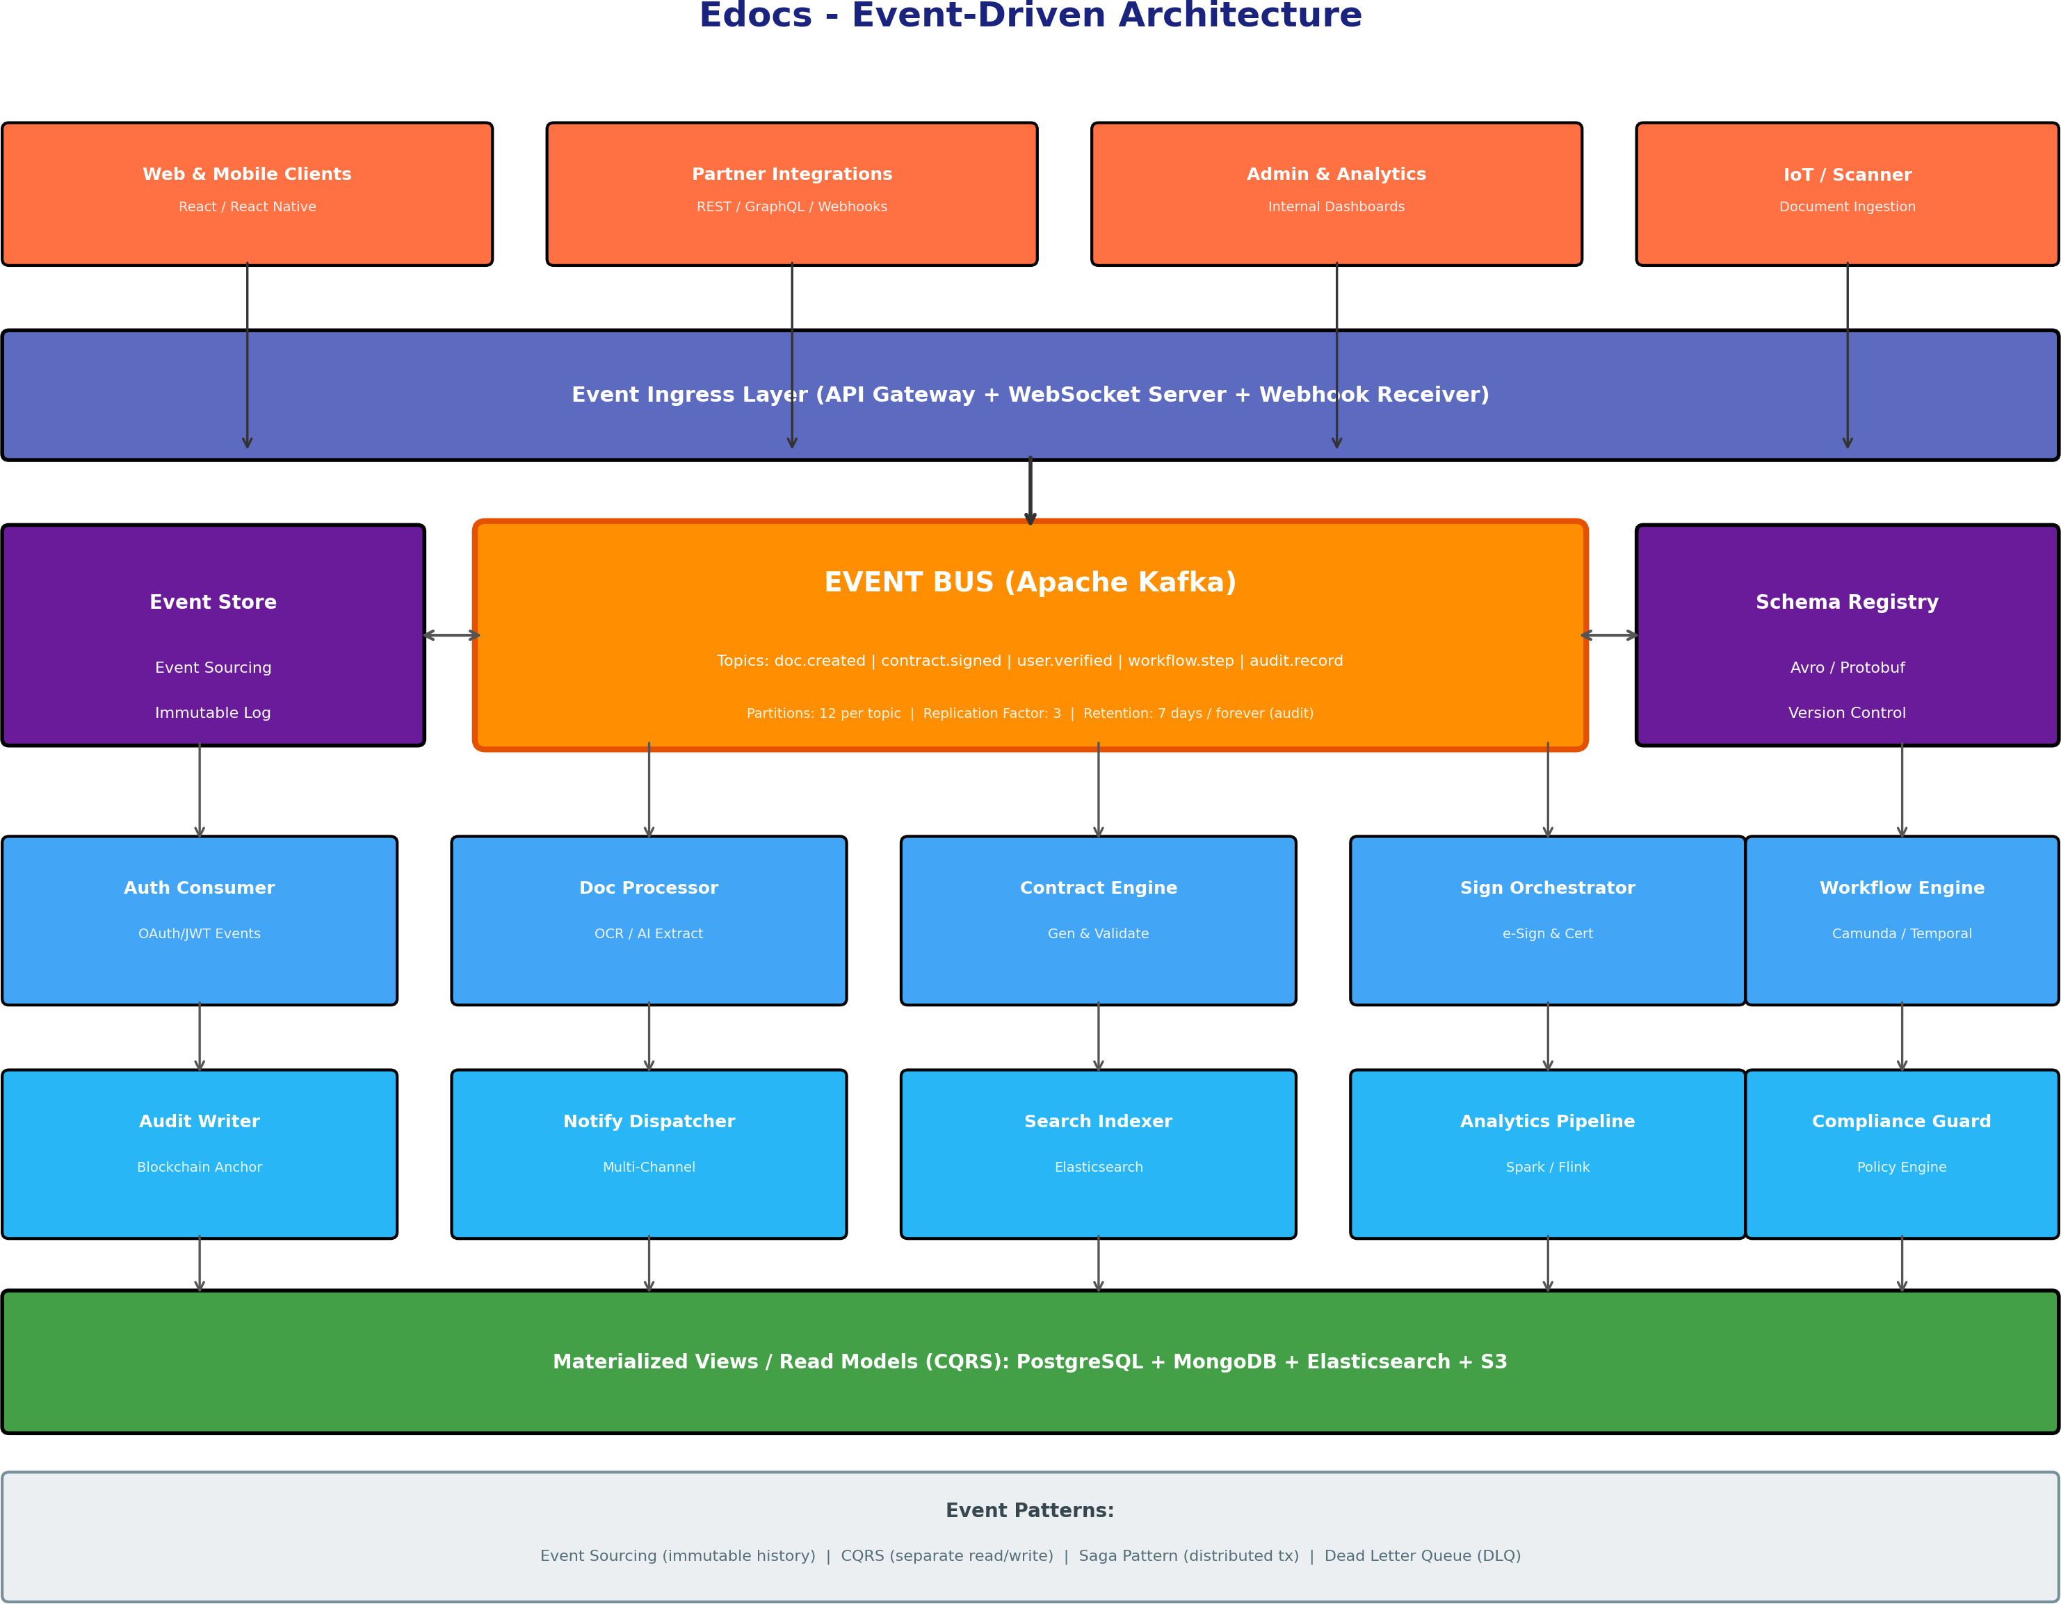
Figure 4: Event-Driven Architecture Diagram

Advantages:
- True Decoupling: Producers and consumers are completely independent. The Contract Engine does not know the Audit Writer exists — it simply publishes events.
- Temporal Decoupling: Consumers can be down for hours and catch up when restored. Critical for audit and analytics workloads.
- Natural Audit Trail: Event sourcing provides an immutable history of every state change. Perfect for legal compliance and dispute resolution.
- Scalability: Kafka partitions enable horizontal scaling of consumers. 10 Audit Writers can process the same topic in parallel.
- Real-Time Capabilities: WebSocket servers push events to clients in real-time. Users see signature status updates instantly.
- Complex Event Processing: Flink/Spark Streaming can detect patterns (e.g., '3 failed signature attempts in 5 minutes') and trigger fraud alerts.
- Replayability: Rebuild any materialized view by replaying events. Bug fixes in the Search Indexer require only reprocessing the event log.

Disadvantages:
- Extreme Complexity: Event sourcing, CQRS, and saga orchestration require senior engineering expertise. Debugging event-driven systems is notoriously difficult.
- Event Schema Evolution: Changing event schemas without breaking consumers requires careful versioning (Avro + Schema Registry).
- Storage Overhead: Event store grows indefinitely. Requires compaction strategies and tiered storage (hot/warm/cold).
- Consistency Complexity: Read models are eventually consistent. Users may see stale data for milliseconds to seconds after a write.
- Operational Burden: Kafka cluster management (ZooKeeper/KRaft), partition rebalancing, and consumer lag monitoring require dedicated platform engineering.
- Not Suitable for Simple CRUD: Overkill for basic operations. Adds unnecessary latency and complexity for straightforward reads.

Recommendation & Rationale
After evaluating all three architectures against Edocs' requirements, we recommend a Hybrid Evolutionary Approach:

Phase 1: Modular Monolith (Months 0-6)
Start with a well-structured monolith using internal module boundaries (Clean Architecture / Hexagonal Architecture). This enables rapid MVP delivery, reduces initial infrastructure costs, and allows the team to validate product-market fit. Modules are separated by package/namespace boundaries but deployed as one unit. Database schema uses schemas (PostgreSQL) or table prefixes to enforce logical separation, preparing for future extraction.

Phase 2: Strangler Fig Pattern (Months 6-12)
Extract high-churn, high-scale, or specialized services first: (1) E-Signature Service — due to compliance isolation needs; (2) AI Document Processor — due to Python/ML stack requirements;
- Notification Service — due to high fan-out patterns. Use the Strangler Fig pattern: route traffic through the API Gateway to new microservices while the monolith handles remaining capabilities.

Phase 3: Event-Driven Core (Months 12-18)
Introduce Kafka as the central nervous system. Migrate state-changing operations to event-sourced aggregates for Audit, Contract Lifecycle, and Workflow domains. Implement CQRS for read-heavy operations (search, analytics dashboards). Retain synchronous REST for simple CRUD operations where eventual consistency is unacceptable (user profile updates).

Rationale Summary:
  - Time-to-Market: Monolith delivers MVP in 3-4 months vs. 8-10 months for full microservices.
  - Risk Mitigation: Premature microservices decomposition is the #1 cause of startup engineering failure.
  - Cost Efficiency: Initial infrastructure under $500/month (monolith) vs. $3,000+/month (microservices).
  - Compliance: E-signature and audit domains benefit most from event sourcing — extract these first.
  - Team Growth: Start with 3-4 engineers on monolith; scale to 15+ engineers across microservices.

Architecture Comparison Matrix:
d)
Criteria | Monolithic | Microservices | Event-DrivenHyb | rid (Recommende
Time to MVP | ★★★★★ | ★★■■■ | ★■■■■ | ★★★★■
Scalability | ★★■■■ | ★★★★★ | ★★★★★ | ★★★★■
Operational Complexity | ★★★★★ | ★★■■■ | ★■■■■ | ★★★■■
Data Consistency | ★★★★★ | ★★★■■ | ★★■■■ | ★★★★■
Team Scalability | ★★■■■ | ★★★★★ | ★★★★■ | ★★★★■
Compliance/Audit | ★★★■■ | ★★★★■ | ★★★★★ | ★★★★★
Infrastructure Cost | ★★★★★ | ★★■■■ | ★★■■■ | ★★★★■
Fault Isolation | ★★■■■ | ★★★★★ | ★★★★★ | ★★★★■

Security & Compliance Framework

Regulatory Compliance
    - eIDAS Regulation (EU): Full support for Simple, Advanced, and Qualified Electronic Signatures. QES uses qualified trust service providers and smart card/USB token integration. Time-stamping authority (TSA) compliance for long-term validation.
    - ESIGN Act & UETA (USA): Intent to sign, consent to electronic records, and association of signature with record are all enforced. Audit trails meet federal court admissibility standards.
    - GDPR (EU): Data minimization, purpose limitation, and storage limitation by design. Right to erasure implemented via cryptographic shredding (key deletion). Data Processing Agreements (DPA) for all sub-processors. EU data residency options via Frankfurt/Dublin regions.
    - SOC 2 Type II: Security, availability, and confidentiality trust service criteria. Annual third-party audits. Penetration testing every 6 months.
    - ISO 27001: Information Security Management System (ISMS) covering asset management, access control, cryptography, physical security, and incident management.
    - HIPAA (Healthcare): Business Associate Agreements (BAA) available. PHI encryption at rest (AES-256) and in transit (TLS 1.3). Audit logging of all PHI access.

Security Architecture
    - Encryption: AES-256-GCM for data at rest. TLS 1.3 for data in transit. Field-level encryption for PII using envelope encryption with KMS.
    - Zero-Trust Network: mTLS between all services. No implicit trust based on network location. Every request authenticated and authorized.
    - Secret Management: HashiCorp Vault with dynamic secrets. Automatic rotation of database credentials, API keys, and signing certificates.
    - DDoS Protection: CloudFlare/AWS Shield Advanced. Rate limiting at edge (10,000 req/min per IP). CAPTCHA challenges for anomalous traffic.
    - Vulnerability Management: Snyk/Dependabot for dependency scanning. SonarQube for static analysis. OWASP ZAP for dynamic scanning in CI/CD.
    - Backup & DR: Point-in-time recovery (PITR) for databases. Cross-region replication (RPO < 1 min, RTO < 15 min). Quarterly disaster recovery drills.

